## **Django Start up**

When you first start create a Directory eg. **Documents.**

Open command line and type ***cd \foldername\*** eg**. cd \Documents\**

Type in the command *py* ***–m venv (name of virtual environment)***

eg. **py –m venv, env**

now is the virtual environment created, lets activate it, by type

***(EN)\Scripts\activate***

eg ***env\Scripts\activate*.**

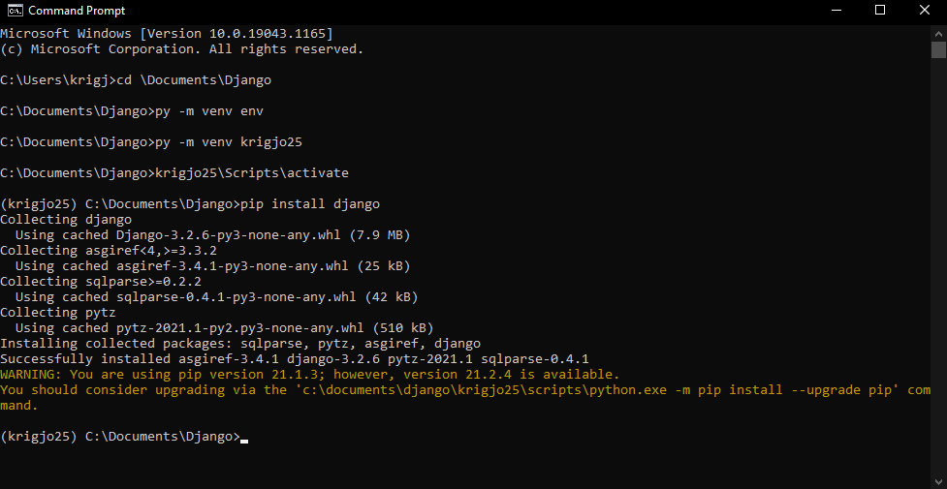The environment is now activated. Next we install Django by typing **pip install Django**

**Figure 1:** [**How to install and use Django (Windows)**](https://www.youtube.com/watch?v=LQTMqGns7Co)

After Django is installed by pip we start the project by type in the command ***django-admin startproject(ProjectName)*** in commandline

**eg. Django-admin startproject DjangoApp**

Open up the path to the Django project and copy the folder over to the coding program, create a new app type in***py manage.py startapp (name of the app)***

eg **py manage.py startapp Demo**

Goto the program where you dropped the code, and SELECT the folder of the ProjectName 🡪 settings.py add (name of the app) under **INSTALLED_APPS**

start the server up by running ***py manage.py runserver.***

Then copy the provided ip address into the browser.

### **Using the admin panel**

Open Cmdline go to the project’s directory using **CD,** Then type in **py manage.py migrate** to create a database for users which is needed in order to store users, next type ***python manage.py createsuperuser*** in command line to create an admin for the ip address/admin follow the given instructions. Open the browser at **127.0.0.1:8000/admin**

### **Hello Django**

Goto the code program and find **views. Define your first function by**

**def** index(request):

**return** render(request, ‘**subdirectory/htmlfile.html**’)

Create a subfolder called template, then another one, add a html file.

Now go to urls.py

Under import

**From The app folder import file** then go down to url patterns type in **path(‘appfoldername/’, ‘ htmlfile’)**

**Eg**

**from Demo.views import index**

**urlpatterns =** [path(‘**Demo/’, index**)]

OR

**from Demo.views import index**

**urlpatterns =** [path(‘ ’, **index**)]

## A Django project’s basic

### **Outer folder / inner folder**

The outer folder is the **root dictionary (djangoproject/)**for Django, can be called anything.

The inner directory is the actual python package for the project (Django/project/filename.py). Which has to be used to import anything with-in the project

### **Manage.py**

A command-line utility where you can interact with Django projects  
details : [Django-admin & manage.py](https://docs.djangoproject.com/en/3.2/ref/django-admin/)

#### **runserver**

### **Settings.py**

Settings/configurations file for the current project [Django settings](https://docs.djangoproject.com/en/3.2/topics/settings/)

### **Urls.py**

Is the URL declarations for this Django project: basically a “table of contents”. [URL dispatcher](https://docs.djangoproject.com/en/3.2/topics/http/urls/)

### **Asgi.py /wsgi**

for ASGI/WSGI-compatible web servers to serve the project